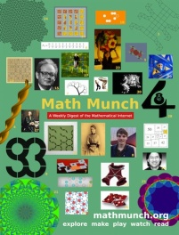
Name: ___________________________ Period: _______
DUE: October 10, 2013
Math Munch Activities for Quarter 1

What is Math Munch? It is an awesome website where math is explored in meaningful, amazing, and inspiring ways. There is something for everyone at Math Munch.
Complete 4 of the 5 tasks below (20 points total) by the end of 1st quarter and turn in your work along with this organizer. Don’t forget to write down the date of the post you use on Math Munch so Mrs. Aldridge can visit the site and read the post too! http://mathmunch.org/
DO  - work on a puzzle  - solve a problem  - struggle with a problem | MAKE  - re-create a piece of math art  - create your own artwork inspired by the original work | WATCH  - watch a video and comment or post about what you learned and/or questions you have | READ  - read about a mathematician and compose two questions you’d like to ask this person | PLAY  - play a math video game, then write a critique of it (likes, dislikes, suggestions, etc.)
Turn in your work on the puzzle/problem on a separate piece of paper. | Turn in your artwork | Turn in a screenshot of your comment or post  or send your comment to me. | Write your two questions in the space below. | Turn in your critique of the game on a separate piece of paper.
date of MM post  ______________  teacher’s initials  ______________ | date of MM post  ______________  teacher’s initials  ______________ | date of MM post  ______________  teacher’s initials  ______________ | date of MM post  ______________  teacher’s initials  ______________ | date of MM post  ______________  teacher’s initials  ______________

